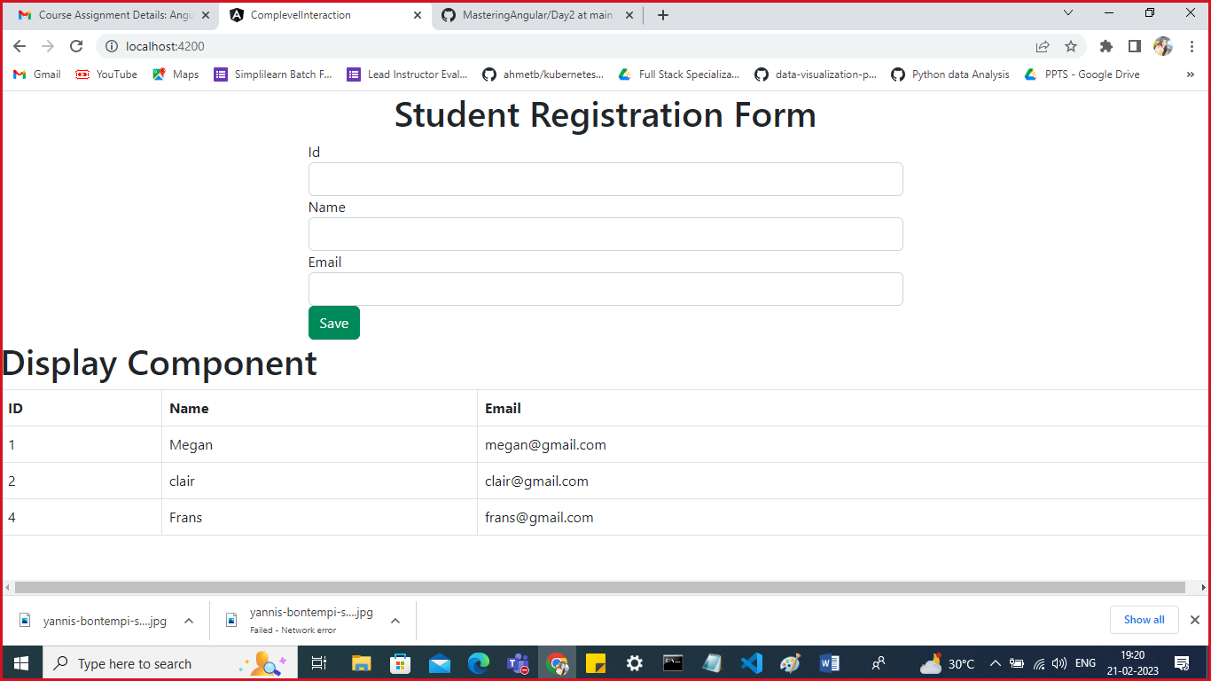

Form Component: Showing Registration Form

Display Comp: Showing the details of Registered Students

Passing Data from form component to Display Component using input.

Form.component.ts

import { Component } from '@angular/core';

@Component({

  selector: 'app-form',

  templateUrl: './form.component.html',

  styleUrls: ['./form.component.css']

})

export class FormComponent {

  myarray:any=[];

  data={id:" ",name:" ",email:" "}

  save(){

    this.myarray.push(this.data);

    this.data={id:" ",name:" ",email:" "}

  }

}

Form.component.html

<h1 class="text-center">Student Registration Form</h1>

<div class="row">

<form class="col-md-6 offset-3">

    <div class="form-group">

        <label>Id</label>

        <input type="text" name="id" placeholder="Id" class="form-control"

        [(ngModel)]="data.id">

    </div>

    <div class="form-group">

        <label>Name</label>

        <input type="text" name="nam" placeholder="name" class="form-control"

        [(ngModel)]="data.name">

    </div>

    <div class="form-group">

        <label>Email</label>

        <input type="text" name="id" placeholder="Email" class="form-control"

        [(ngModel)]="data.email">

    </div>

    <button class="btn btn-success" (click)="save()">Save</button>

</form>

<app-display [myarray]="myarray"></app-display>

</div>

Display.component.ts

import { Component } from '@angular/core';

@Component({

  selector: 'app-display',

  templateUrl: './display.component.html',

  styleUrls: ['./display.component.css'],

  inputs:['myarray']

})

export class DisplayComponent {

  myarray:any=[];

}

Display.component.html

<h1> Display Component</h1>

<table class="table table-bordered">

    <thead>

        <tr>

            <th>ID</th>

            <th>Name</th>

            <th>Email</th>

        </tr>

    </thead>

    <tbody>

        <tr \*ngFor="let d of myarray">

            <td>{{d.id}}</td>

            <td>{{d.name}}</td>

            <td>{{d.email}}</td>

        </tr>

    </tbody>

</table>

Make sure you import FormsModule in app.module.ts

import { NgModule } from '@angular/core';

import { FormsModule } from '@angular/forms';

import { BrowserModule } from '@angular/platform-browser';

import { AppRoutingModule } from './app-routing.module';

import { AppComponent } from './app.component';

import { ChildComponent } from './child/child.component';

import { FormComponent } from './form/form.component';

import { DisplayComponent } from './display/display.component';

@NgModule({

  declarations: [

    AppComponent,

    ChildComponent,

    FormComponent,

    DisplayComponent

  ],

  imports: [

    BrowserModule,

    AppRoutingModule,

    FormsModule

  ],

  providers: [],

  bootstrap: [AppComponent]

})

export class AppModule { }

make sure you include form component in app.component.html

<app-form></app-form>